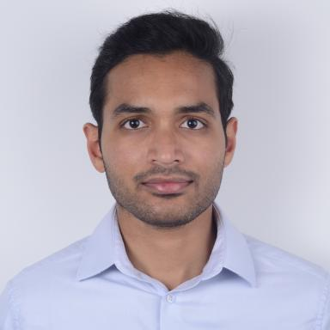 Siddhartha H. OMMI Maître de Conférences (Associate Professor)

Identifiants chercheurs

- IdHAL :
siddhartha-ommi
- ORCID :
0000-0002-6199-7495

Publications

Article dans une revue (6)

Swelling-driven mechanics of partially cross-linked polymer gels: Steady state solutions
Paola Nardinocchi,Siddhartha Ommi,Giulio Sciarra
International Journal of Engineering Science, 2024, 202, pp.104101. ⟨10.1016/j.ijengsci.2024.104101⟩
Article dans une revue
hal-04627350v1
Fingering and strain localization in porous media during imbibition processes
Mohammed Zaim,Siddhartha Harsha Ommi,Frédéric Collin,Panagiotis Kotronis,Giulio Sciarra
International Journal for Numerical Methods in Engineering, 2023, 124 (16), pp.3554-3581. ⟨10.1002/nme.7261⟩
Article dans une revue
hal-04223416v1
A phase field model for partially saturated geomaterials describing fluid-fluid displacements. Part I: The model and one-dimensional analysis
Siddhartha Ommi,Giulio Sciarra,Panagiotis Kotronis
Advances in Water Resources, 2022, 164, pp.104170. ⟨10.1016/j.advwatres.2022.104170⟩
Article dans une revue
hal-03633296v1
A phase field model for partially saturated geomaterials describing fluid-fluid displacements, Part II: Stability analysis and two-dimensional simulations
Siddhartha Ommi,Giulio Sciarra,Panagiotis Kotronis
Advances in Water Resources, 2022, 122, pp.104201. ⟨10.1016/j.advwatres.2022.104201⟩
Article dans une revue
hal-03650361v1
Variational Approach to Damage Induced by Drainage in Partially Saturated Granular Geomaterials
Siddhartha Ommi,Giulio Sciarra,Panagiotis Kotronis
Frontiers in Mechanical Engineering, 2022, 8, ⟨10.3389/fmech.2022.869568⟩
Article dans une revue
hal-03843622v1
A phase field model for partially saturated geomaterials describing fluid–fluid displacements, Part II: Stability analysis and two-dimensional simulations
Siddhartha Ommi,Giulio Sciarra,Panagiotis Kotronis
Advances in Water Resources, 2022, 164, pp.104201. ⟨10.1016/j.advwatres.2022.104201⟩
Article dans une revue
hal-05552227v1

Thèse (1)

Study of hydro-mechanical instabilities in geomaterials
Siddhartha Harsha Ommi
Civil Engineering. École centrale de Nantes, 2022. English. ⟨NNT : 2022ECDN0017⟩
Thèse
tel-03869550v1

