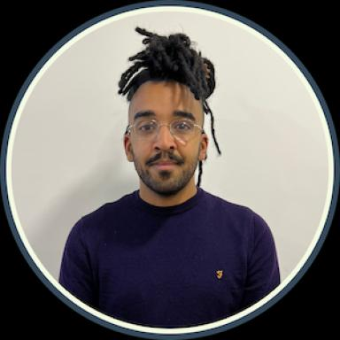 Simon Fagour ATER en histoire contemporaine — IHEAL, USNDoctorant en histoire contemporaine

Identifiants chercheurs

- IdHAL : simon-fagour

Publications

Communication dans un congrès (4)

Parallel Paths to the Third World : Cuba, Brazil and the Aborted Conference of Underdeveloped Countries in the Early 1960s
Simon Fagour,Flores Giorgini
Seminario de Historia International (SHI), Università Ca' Foscari de Venise, Nov 2026, Venise (Italie), Italy
Communication dans un congrès
hal-05552378v1
The Cuban Revolution and Caribbean Nationalism: Independance Movements and Counter-Revolution in French and British Colonial Territories, 1959-1964
Simon Fagour
Seminar in Cuban and Cuban Diaspora Studies (Fall 2025-Spring 2026), University of Miami, Cuban Heritage Collection, May 2026, Miami (Florida), United States
Communication dans un congrès
hal-05552379v1
This Castro is really the very devil&quot; : Western Europe Countries Dealing with Cuba in the Early Years of the Revolution, 1959-1963
Simon Fagour
Graduate Student Conference on the Cold War, Wilson Center/George Washington University (GWU), London School of Economics (LSE), University of California Santa Barbara (UCSN), May 2024, Washington D.C, United States
Communication dans un congrès
hal-05552377v1
The Ghost of Guevara: Western Europe Embassies Coping with Student Travels to Cuba in 1968
Simon Fagour
LSE International History Seminar (HY509, Winter Terms), London School of Economics (LSE), Feb 2024, London (U.K.), United Kingdom
Communication dans un congrès
hal-05552384v1

