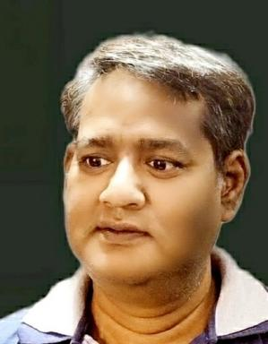 Singh Ajit

Identifiants chercheurs

- IdHAL : singh-ajit
- ORCID : 0000-0002-6093-3457
- ResearcherID : C-5312-2019

Publications

Communication dans un congrès (1)

Data Lakes Technologies and It's Significant Implementations
Singh Ajit Singh Ajit,Sultan Ahmad
MOL2NET 2021, International Conference on Multidisciplinary Sciences, 7th edition session USEDAT-07: USA-Europe Data Analysis Training Program Workshop, Cambridge, UK-Bilbao, Spain-Miami, USA, 2021, Jun 2021, Basel, Switzerland
Communication dans un congrès
hal-03261762v1

Article dans une revue (1)

COMMUNICATION COROUTINES FOR PARALLEL PROGRAM USING DW26010 MANY CORE PROCESSOR
Singh Ajit Singh Ajit
INTERCATHEDRA, 2021, 2020, 44 (3), ⟨10.17306/J.INTERCATHEDRA.2020.00104⟩
Article dans une revue
hal-03242031v1

