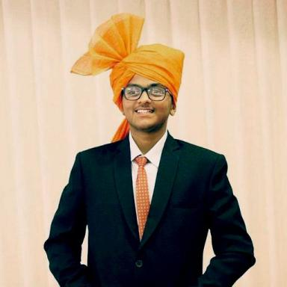 Smit Shetye

Identifiants chercheurs

- IdHAL : smitshetye
- ORCID : 0000-0002-2126-1547
- VIAF : 3806162669364155500009
- ISNI : 0000000495508412
- ResearcherID : ABG-5077-2021

Présentation

Publications

Rapport (1)

Notepad in Java
Smit Shetye,Sarwesh Nandeshwar,Avinash Tiwari
[Technical Report] Shivajirao S. Jondhale College of Engineering. 2021, pp.28
Rapport (rapport technique)
hal-03498209v1

