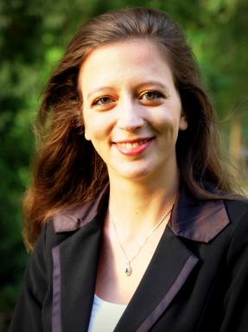 Sonia Ben Hamida

Présentation

I have been working as a system engineer since 2011 at Airbus Safran Launchers (ASL), the European leader in space transport. First, I took part in the Single European Sky Air Traffic Management Research (SESAR) program for 2 years. Then, I started a Ph.D. in partnership with the research institute SystemX and the École CentraleSupélec – one of the top French research institutes in system design. My research focuses on how to design value proposition for new businesses under uncertainty.
I hold an engineer’s degree in aerospace from the French Civil Aviation grande école. I published in the Conference on Systems Engineering Research (CSER), CERN PURESAFE, the International Conference on Engineering Design (ICED) and the International Design Engineering Technical Conferences (IDETC). I am a member of the French INCOSE chapter and the Design Society.
I will defend my Ph.D. early 2017. I am currently involved in ASL’s concept studies and innovative projects.

Publications

