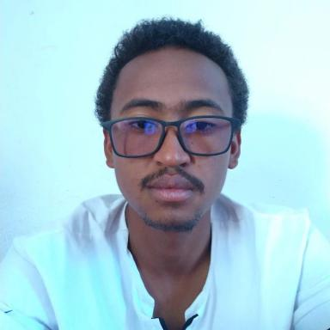 Stefana Fandresena TABERA TSILEFA I work on my PhD project which is about computational and theoretical probability

Identifiants chercheurs

- IdHAL : stefanatsilefa
- ORCID : 0000-0003-4302-6609
- cv.identifier.google scholar : https://scholar.google.fr/citations?user=mdRZ-0EAAAAJ

Publications

Article dans une revue (2)

Bayesian inference of a spatially dependent semi-Markovian model with application to Madagascar Covid'19 data
Angelo Fulgence Raherinirina,Stefana Tabera Tsilefa,Tsidikaina Nirilanto,Solym Manou-Abi
PLoS ONE, 2025, 20 (7), pp.e0326264. ⟨10.1371/journal.pone.0326264⟩
Article dans une revue
hal-05166340v1
Spatial markov for measuring the spatial dependencies of an epidemiological spread : case covid'19 Madagascar
Stefana Tabera Tsilefa,Angelo Fulgence Raherinirina
BMC Public Health, 2024
Article dans une revue
hal-04371260v4

Communication dans un congrès (2)

A lattice structure in statistical implicative analysis
Fidy Heritiana Andrianarivony,Elinambinina Rajaonarifara,Stefana Tabera Tsilefa,Angelo Fulgence Raherinirina,Jean-Claude Régnier
International Conference on Artificial Intelligence and Applied Mathematics (JIAMA24), Ahmed TOUKMATI, Abderrahim ZANNOU - ENSA, Al-Hoceima, May 2024, Al-Hoceima, Morocco
Communication dans un congrès
hal-04572544v1
Numerical convergence of some stochastic compartmental models in epidemiology
Stefana Fandresena Tsilefa,Solym Mawaki Manou-Abi,Angelo Raherinirina
CARI 2022, Oct 2022, Tunis, Tunisia
Communication dans un congrès
hal-03715840v1

