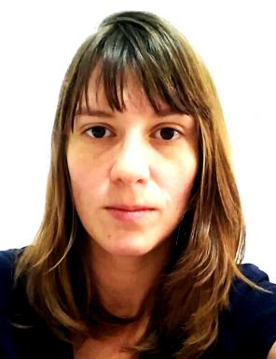 Stephanie Roedel

Présentation

Ph.D. Student at Federal University of Santa Catarina (UFSC) since October/2019. Member of the Ceramic & Composite Materials Research Laboratories (CERMAT). Research theme: Direct ink writing of carbon nanophase reinforced calcium phosphate cements for tissue engineering applications.
Master in Materials Science & Engineering by UFSC (2017). Research theme: Functionally graded materials - Graded macroporosity on zirconia substrates obtained by dip coating method.
Biodesign Bootcamp – Intensive experience of two weeks in Biodesign applied to Health Systems at Pontifícia Universidade Católica do Paraná (PUC-PR), given by Stanford University professionals. Best innovation project applied at health system award (2016).
Materials Engineer at Centro Universitário da FEI (2013).
Experience in Supply Chain, Operational and Logistics areas. Knowledge in SAP system.
Expertise in project structuring (schedule, strategic diagrams, data analysis), in Design Thinking, business model, visual strategies and pitching.
Good social skills in relating to work with multidisciplinary teams and people from different cultures. Autodidact seamstress and artisan; independent consultant (R&D).
Mother tongue: Portuguese; Fluent English and French; Advanced Spanish.

Publications

Communication dans un congrès (1)

Rheo-SAXS-WAXS investigation of the setting process of β-gypsum plaster and calcium phosphate cements
Alexandre Fantou,Laurent Gremillard,William Chèvremont,Guilhem P Baeza,Yves Jorandet al.
18th ECerS congress, Jul 2023, Lyon, France. ⟨10.15151/ESRF-ES-998388450⟩
Communication dans un congrès
hal-05222957v1

