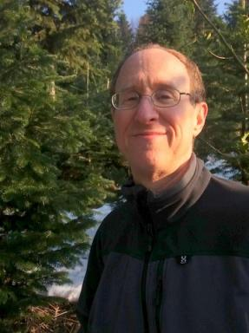 Steven Kaplan

Publications

Article dans une revue (1)

Boys will be boys: an example of biased and exclusive usage
Steven M Kaplan
Lexicographica. International Annual for Lexicography, 2020, Metalexicography, dictionaries and culture - Edited by Rufus H. Gouws, 36, pp.205-223
Article dans une revue
hal-04072817v1

Communication dans un congrès (1)

The role lexicographers can play in helping to vanquish insensitivity, brutality, othering, and wilful ignorance
Steven M Kaplan
25th International AFRILEX (African Association for Lexicography ) Conference, Jun 2021, Stellenbosch, South Africa
Communication dans un congrès
hal-03898094v1

Notice d’encyclopédie ou de dictionnaire (1)

America and American in contraposition to USA and US American.
Steven M Kaplan
Some lexicographical and sociolinguistic considerations., 2024
Notice d’encyclopédie ou de dictionnaire
hal-04663212v1

Pré-publication, Document de travail (9)

otra chingada mas – un poema con 100 palabras
Steven M Kaplan
2024
Pré-publication, Document de travail
hal-04763030v1
“-Hyphenated-Americans:” the quintessential “all-American” way of othering.
Steven M Kaplan
2024
Pré-publication, Document de travail
hal-04733331v1
Valerie Jean Solanas – Supermujer promotora del poder femenino
Steven M Kaplan
2024
Pré-publication, Document de travail
hal-04679877v1
social constructions – the core of our biased and inequitable reality: Part One
Steven M Kaplan
2024
Pré-publication, Document de travail
hal-04421559v2
social constructions – the core of our biased and inequitable reality, Part Two: Rape, Patriarchy, and Genocide
STEVEN M KAPLAN
2024
Pré-publication, Document de travail
hal-04602077v1
Spinster -In-depth and unbiased
Steven M Kaplan
2023
Pré-publication, Document de travail
hal-04026114v1
senior moment - a typical example of how older people are othered
Steven M Kaplan
2023
Pré-publication, Document de travail
hal-04308106v1
Valerie Jean Solanas - SuperWoman Power Advocate
Steven M Kaplan
2024
Pré-publication, Document de travail
hal-04701171v1
Some verses for Boye -Scholl -Solanas
Steven M Kaplan
2025
Pré-publication, Document de travail
hal-04971530v1

Thèse (1)

A Theoretical Model for the Preparation of an Inclusive and Bias-Free Expression Dictionary
Steven M Kaplan
Sociology. Stellenbosch University, 2020. English. ⟨NNT : ⟩
Thèse
tel-02458629v1

