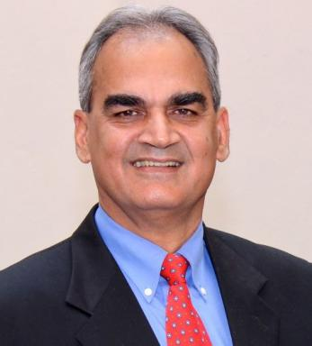 Sunil Sondhi Tagore National FellowIndira Gandhi National Center for the ArtsNew DelhiINDIA

Publications

Rapport (1)

DANDANITI IN THE INDIAN TRADITION
Sunil Sondhi
Indira Gandhi National Center for the Arts; IGNCA Janpath New Delhi-110001India https://ignca.gov.in/. 2025, pp.101
Rapport
hal-05320608v2

Pré-publication, Document de travail (5)

Punishment Policy in the Vedic Tradition
Sunil Sondhi
2025
Pré-publication, Document de travail
hal-05213709v1
Creative Communication
Sunil Sondhi
2024
Pré-publication, Document de travail
hal-04571420v1
Hindu Law in Greater India
Sunil Sondhi
2024
Pré-publication, Document de travail
hal-04680701v1
The Concept of Danda in the Dharmasastra A Unifying View of Spirit and Force of Dharma in Indian Tradition
Sunil Sondhi
2023
Pré-publication, Document de travail
hal-04117909v1
ASPECTS OF DHARMA Ethics Law and Action in Indian Tradition
Sunil Sondhi
2023
Pré-publication, Document de travail
hal-04188649v1

Communication dans un congrès (4)

THE DHARMASASTRA AND MODERN LAW Letter and Spirit of Law in Indian Tradition
Sunil Sondhi
Vedic Nyaya Samagam, Banaras Hindu University, Mar 2024, Varanasi (U.P.), India
Communication dans un congrès
hal-04512415v1
SAMVAD: The Indian Communication Tradition
Sunil Sondhi
Bharatvarshiya Communication Tradition, Bhawanipore Education Society College, Nov 2024, Kolkata, India
Communication dans un congrès
hal-04859603v1
India's Cultural Imprint in Asia*
Sunil Sondhi
Global Presence of India Civilisation, India International Center, Sep 2023, New Delhi, India
Communication dans un congrès
hal-03964481v1
Hindu Sociology
Sunil Sondhi
Revisiting Binoy Kumar Sen's Contribution to Hindu Sociology, Nov 2022, Varanasi, India
Communication dans un congrès
hal-03916749v1

Article dans une revue (4)

Sabdapurvayoga: Indian Communication Theory and Practice
Sunil Sondhi
Kalakalpa IGNCA Journal for Arts, 2022
Article dans une revue
hal-03568597v1
Science and Spirit of Language in Indian Culture
Sunil Sondhi
Kalakalpa IGNCA Journal for Arts, 2021
Article dans une revue
hal-03225767v1
Sabda Brahma: Science and Spirit of Language in Indian Tradition
Sunil Sondhi
Kalakalpa IGNCA Journal for Arts, 2021, V (2)
Article dans une revue
hal-03372632v1
Sabdanusanam: The Integral View of Communication
Sunil Sondhi
Kalakalpa IGNCA Journal for Arts, 2020
Article dans une revue
hal-03226086v1

