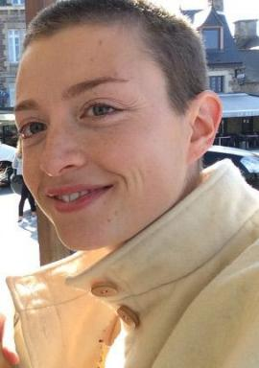 Süzel Horellou

Présentation

Publications

Communication dans un congrès (2)

Deciphering the role of neuromuscular junctions in infantile Pompe disease pathogenesis
Tiffany Bourgeton,Suzel Horellou,Julie-Anne Balouek,Candice Babarit,Sabrina Jagotet al.
NeurATRIS Translational Neurosciences Day, May 2024, Pornichet - La Baule, France
Communication dans un congrès
hal-04988000v1
Assessing marine biotechnology research centres in peripheral regions: developing global and local STI indicators
Douglas K. R. Robinson,Antoine Schoen,Patricia Laurens,Suzel Horellou,Pierre Colaset al.
STI2016 - Proceedings of the 21ST international conference on science and technology indicators, Sep 2016, Valencia, Spain. ⟨10.4995/STI2016.2016.4543⟩
Communication dans un congrès
hal-01704087v1

