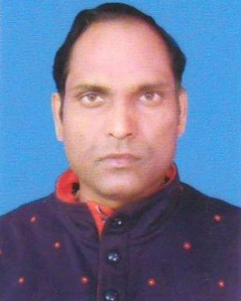 Tapan Gorai

Identifiants chercheurs

- IdHAL : tapan-gorai
- ORCID : 0000-0003-2928-6850
- ResearcherID : K-7086-2016

Publications

Article dans une revue (8)

Mapping Spatial Variation of Soil Carbon Concentration and Assessment of Carbon Stocks in an Agricultural Farm of Semiarid Region of India
Tapan Gorai,Nayan Ahmed,Sankar Kumar Mahapatra,Rabi Narayan Sahoo,Priyabrata Santra
International Journal of Environment and Climate Change, 2025, 15 (10), pp.507-529
Article dans une revue
hal-05329833v1
Predictive Mapping of Soil Micronutrients Using Geographic Information System for Site Specific Management Interventions in a Semiarid Farm, India
Tapan Gorai,Nayan Ahmed,Rabi Narayan Sahoo
International Journal of Plant & Soil Science, 2024, 36 (7), pp.859-874. ⟨10.9734/ijpss/2024/v36i74798⟩
Article dans une revue
hal-04631242v1
Farm-Scale Mapping of Soil Microbiological Indicators Using Geostatistical Technique
Tapan Gorai,Nayan Ahmed,Rabi Narayan Sahoo
International Journal of Environment and Climate Change, 2023, 13 (11), pp.1439-1451. ⟨10.9734/IJECC/2023/v13i113296⟩
Article dans une revue
hal-04631243v1
Farm-scale Mapping of Soil Phosphorus and Potassium Fractions Using Geostatistical Technique
Tapan Gorai,Nayan Ahmed,Rabi Narayan Sahoo
International Journal of Plant & Soil Science, 2022, 34 (23), pp.1257-1270
Article dans une revue
hal-05202251v1
Farm-scale Mapping of Soil Phosphorus and Potassium Fractions Using Geostatistical Technique
Tapan Gorai,Nayan Ahmed,Rabi Narayan Sahoo
International Journal of Plant & Soil Science, 2022, pp.1257-1270. ⟨10.9734/ijpss/2022/v34i232541⟩
Article dans une revue
hal-04631244v1
Evaluation of Clusterbean (Cyamopsis tetragonoloba L.) Varieties for Koshi Region of Bihar
G.L. Choudhary,Seema Kumari,Paras Nath,P.K. Yadav,Tapan Gorai
LEGUME RESEARCH - AN INTERNATIONAL JOURNAL, 2022, Of, ⟨10.18805/LR-4908⟩
Article dans une revue
hal-04631247v1
Site-specific Crop Nutrient Management for Precision Agriculture – A Review
Tapan Gorai,Pankaj Kumar Yadav,Gopal Lal Choudhary,Anil Kumar
Current Journal of Applied Science and Technology, 2021, 40 (10), pp.37-52
Article dans une revue
hal-05243242v1
To Determine the Structure and Function of Bhagar Oxbow Lake in Dumraon, Buxar, South Bihar, India
Suday Prasad,Subodh Kumar,Tapan Gorai,Ajay Kumar
Current Journal of Applied Science and Technology, 2020, 39 (28), pp.145-153
Article dans une revue
hal-05319036v1

