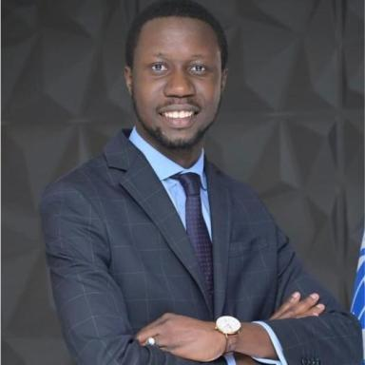 Thierno Bocar DIOP

Présentation

I am an Economist working on evaluating agri-environmental subsidies, agricultural trade policies, public expenditure, innovative finance, climate adaptation and food security across Africa and Europe. I have been awarded the Best Young Researcher special prize at JRSS 2022.
I will be joining the UN Food and Agriculture Organization (FAO) as an Economist (Trade Analyst) from February 2025 in Rome, Italy. Previously, I worked at the World Trade Organization (WTO) in Geneva, Switzerland, and at the UN Economic Commission for Africa (UNECA) in Addis Ababa, Ethiopia. Before that, I was a Junior Research Fellow at France's National Research Institute for Agriculture, Food and the Environment (INRAE) in Dijon, France. I also consulted for IPAR Think Tank in Dakar, Senegal.
I hold a Ph.D. in Economics from UMR CESAER, INRAE in France, a double Master's degree in Development Economics and Analysis of Development Projects from the University of Clermont Auvergne, CERDI in France, and a double Bachelor's degree in Development Economics from the University of Clermont Auvergne, CERDI, and in Economics from the Cheikh Anta Diop University of Dakar, Senegal.Please visit my webpage https://sites.google.com/view/thierno-bocar-diop/homepage

Publications

Article dans une revue (3)

Exploring the linkages between farm efﬁciency, farm environmental performance, and agri-environmental scheme adoption: lessons from France
Thiernobocar Diop,Stéphane Blancard,Sophie Legras,Sébastien Marchand,Lionel Védrine
Journal of Environmental Management, 2024, 366, pp.121519. ⟨10.1016/j.jenvman.2024.121519⟩
Article dans une revue
hal-04663722v1
Les politiques publiques permettent-elles de concilier performances économiques et performances environnementales des exploitations agricoles ?
Thierno Bocar Diop
INRAE Sciences Sociales, 2021, 4-5/2021 (5), 2 p
Article dans une revue
hal-03800830v1
Quality of life in cancer patients undergoing anticoagulant treatment with LMWH for venous thromboembolism: the QUAVITEC study on behalf of the Groupe Francophone Thrombose et Cancer (GFTC)
Dominique Farge,Francis Cajfinger,Nicolas Falvo,Toufek Berremili,Francis Couturaudet al.
Oncotarget, 2018, 9 (43)
Article dans une revue
hal-02055888v1

Thèse (1)

Do public policies promote a better balance between the economic and environmental performance of farms?
Thierno Bocar Diop
Humanities and Social Sciences. Université Bourgogne Franche-Comté, 2023. English. ⟨NNT : 2023UBFCG013⟩
Thèse
tel-04383787v1

