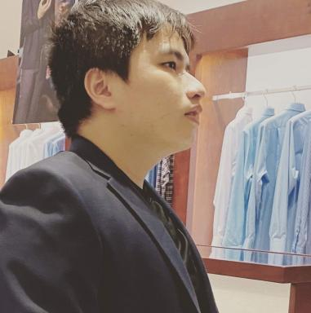 Thanh Vuong DANG

Publications

Pré-publication, Document de travail (1)

On the boundary controlled wave equation
Thanh Vuong Dang
2024
Pré-publication, Document de travail
hal-04463449v1

Thèse (1)

Parallel in time algorithms for internal wave controlled problem
Thanh Vuong Dang
Mathematics [math]. Université Paris 13 Sorbonne Paris Nord, 2023. English. ⟨NNT : 2023PA131081⟩
Thèse
tel-04701863v2

