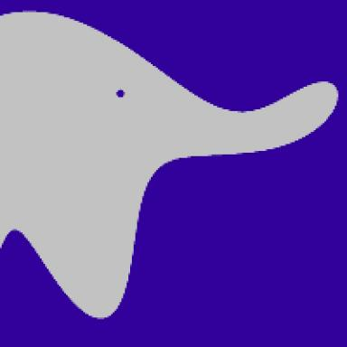 Théo Rudkiewicz

Identifiants chercheurs

- IdHAL : theo-rudkiewicz
- ORCID : 0009-0003-4374-531X

Publications

Pré-publication, Document de travail (1)

Distribution-aware tensor decomposition for compression of convolutional neural networks
Alper Kalle,Théo Rudkiewicz,Mohamed-Oumar Ouerfelli,Mohamed Tamaazousti
2026
Pré-publication, Document de travail
cea-05569665v1

Communication dans un congrès (2)

Growth strategies for arbitrary DAG neural architectures
Stella Douka,Manon Verbockhaven,Théo Rudkiewicz,Stéphane Rivaud,François P. Landeset al.
ESANN 2025 - 33th European Symposium on Artificial Neural Networks, Apr 2025, Bruges, Belgium. ⟨10.14428/esann/2025.ES2025-112⟩
Communication dans un congrès
hal-04902059v2
Robustness of tensor decomposition-based neural network compression
Théo Rudkiewicz,Mohamed-Oumar Ouerfelli,Riccardo Finotello,Zakariya Chaouai,Mohamed Tamaazousti
ICIP 2024 - IEEE International Conference on Image Processing, Oct 2024, Abu Dhabi, United Arab Emirates. pp.221-227, ⟨10.1109/ICIP51287.2024.10647942⟩
Communication dans un congrès
cea-05029995v1

Article dans une revue (1)

Growing Tiny Networks: Spotting Expressivity Bottlenecks and Fixing Them Optimally
Manon Verbockhaven,Théo Rudkiewicz,Sylvain Chevallier,Guillaume Charpiat
Transactions on Machine Learning Research Journal, 2024
Article dans une revue
hal-04591472v2

