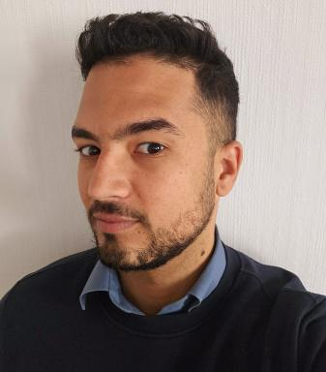 Thomas Boyer PhD Cifre: Geography/Urbanism with UMR ESPACE & AUA - emc2 European research program - Using ABM to evaluate the emc2 urban model in periurban metropolitan areas

Identifiants chercheurs

- IdHAL : thomas-boyer
- ORCID : 0009-0002-8568-2129

Présentation

PRESENTATION:I am Thomas BOYER, 25 years old, originally from the island of La Réunion. My background includes:
Doctoral candidate in geography and urban planning.Affiliated with UMR ESPACE at Campus Carlone, IMREDD (CNRS division), and the Agence d'Urbanisme Azuréenne (industrial sector).
THESIS PROJECT FRAMEWORK:
European consortium (HORIZON) led by G. FUSCO: CNRS (UMR ESPACE), Agence d'Urbanisme Azuréenne (AUA), Chalmers University of Technology (SMoG), University of Pisa (DESTEC), Vienna University of Technology (Urban Design Department), City of Gothenburg, City of Viareggio, and the Urban Planning Agency of Lille Métropole.
Objectives of the European consortium: Evaluate a new model of the 15-minute city, adapted for peripheral and peri-urban areas, known as the Evolutive Mesh Compact City (EMC2).
Scientific direction: Giovanni FUSCO (HDR, Director of UMR ESPACE Nice).Co-scientific direction: Diego MORENO-SIERRA (MC, UMR ESPACE - University of Côte d'Azur).
Industrial direction: Laurence JACQUIER (Urbanist-Landscape Architect, Director of the Studies Division at AUA).
MY THESIS PROJECT:
Scientific challenges: Understand the human constraints for implementing the 15-minute city through multi-agent modeling to assess its feasibility in the planning of peri-urban areas in the Azuréenne region.
Problematic: How to integrate user behaviors, in terms of spatiality, mobility, and the use of public spaces, to promote the success of a 15-minute city policy through a network of densification axes in a peri-urban space?
Keywords: 15-minute city, Peri-urban, Multi-Agent System, Territorial Simulation, Prospective.
EUROPEAN RESEARCH PROGRAM WEBSITE : https://emc2-dut.org/
THESIS DESCRIPTION ON UMR ESPACE WEBSITE :https://www.umrespace.org/actualite/thomas-boyer-modeliser-les-pratiques-de-lespace-periurbain-pour-identifier-le-potentiel-de-la-ville-du-quart-dheure-une-approche-multi-agent-pour-le-periurbain-azureen/
ARTICLES :Link to Research Article 1 : https://link.springer.com/chapter/10.1007/978-3-031-37105-9_23Link to Presentation Video : https://www.youtube.com/watch?v=UjiH8O5vKIILink to Research Article 2 : https://zenodo.org/record/7818160

Publications

Communication dans un congrès (1)

Sustainable Aging in Aix-Marseille-Provence Metropolis: Assessment Indicators and Interactive Visualizations for Policy Making
Joan Perez,Araldi Alessandro,Boyer Thomas,Bridier Sébastien,Decoupiny Fabriceet al.
The 24th International Conference on Computational Science and Its Applications, Jul 2023, Athens, Greece. pp.339-353, ⟨10.1007/978-3-031-37105-9_23⟩
Communication dans un congrès
halshs-04323263v1

