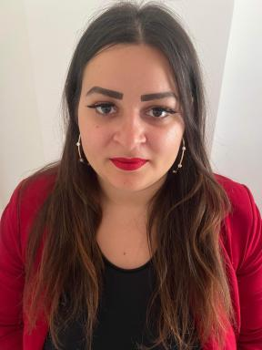 Tiffany Bourgeton Doctorante en 3ème année pourtant sur : l'effet de l'enzymothérapie sur le muscle squelettique dans la maladie de Pompe : focus sur l'autophagie et les cellules satellites.

Identifiants chercheurs

- IdHAL : tiffany-bourgeton

Publications

Pré-publication, Document de travail (2)

Intracellular Membrane Repair Dysregulation and Accumulation of Mature Myostatin Protein are Novel Markers of Muscle Pathophysiology in Pompe Disease
Candice Babarit,Sabrina Jagot,Cindy Schleder,Johan Deniaud,Tiffany Bourgetonet al.
2026
Pré-publication, Document de travail
hal-05487367v1
Transgene-Induced Cardiotoxicity In High-Dose AAV Gene Transfer
Ariane Biquand,Evelyne Gicquel,Jérôme Poupiot,Marine Faivre,Stephany Campuzanoet al.
2025
Pré-publication, Document de travail
hal-05398539v1

Poster de conférence (2)

Intracellular Membrane Repair Dysregulation and Accumulation of Mature Myostatin Protein are Novel Markers of Muscle Pathophysiology in Pompe Disease
Candice Babarit,Sabrina Jagot,Cindy Schleder,Johan Deniaud,Tiffany Bourgetonet al.
Journées de la Société française de myologie, Nov 2025, Aix les bains, France
Poster de conférence
hal-05462837v1
Is the mitochondria a key player in the pathogenesis of Pompe disease? Focus on muscle metabolism and ERT impact
Tiffany Bourgeton,Axel You,Johan Deniaud,Marie Raballand,Sophie Burelet al.
Colloque AFM, 2025, Paris, France
Poster de conférence
hal-05467406v1

Communication dans un congrès (3)

Effect of enzyme therapy on skeletal muscle in Pompe disease focus on autophagy
Tiffany Bourgeton
Life sciences, Apr 2025, Nantes, France
Communication dans un congrès
hal-05467371v1
The metabolic status of skeletal muscle fibers influences the precocity and severity of damages in Pompe disease
Tiffany Bourgeton
Journées de la Société française de Myologie, Nov 2025, Aix-Les-Bains, France
Communication dans un congrès
hal-05462792v1
Deciphering the role of neuromuscular junctions in infantile Pompe disease pathogenesis
Tiffany Bourgeton,Suzel Horellou,Julie-Anne Balouek,Candice Babarit,Sabrina Jagotet al.
NeurATRIS Translational Neurosciences Day, May 2024, Pornichet - La Baule, France
Communication dans un congrès
hal-04988000v1

