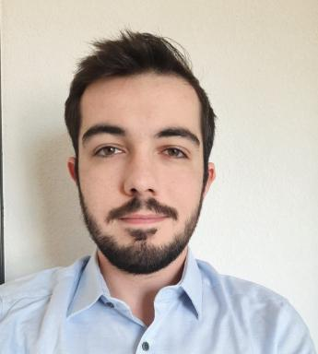 Timothée Labau Doctorant CIFRE : GaN Cascode et RadiationsCollaboration CEA Leti / Delphea

Identifiants chercheurs

- IdHAL : timothee-labau
- ORCID : 0009-0007-5409-1584

Publications

Article dans une revue (1)

The Use of High Energy X-Ray Generators for TID Testing of Electronic Devices
Vincent Girones,Jérôme Boch,Alain Carapelle,Arnaud Chapon,Tadec Maraineet al.
IEEE Transactions on Nuclear Science, 2023, pp.1-1. ⟨10.1109/TNS.2023.3279626⟩
Article dans une revue
hal-04124251v1

Communication dans un congrès (1)

Comparative analysis of SEGR and SEB susceptibility in Si and SiC MOSFETs using TCAD modeling
Cleiton Marques,Alain Michez,Timothée Labau,Rosine Coq Germanicus,Frédéric Wrobelet al.
RADECS 2025 - RADiation and its Effects on Components and Systems Conference, Sep 2025, Anvers, Belgium
Communication dans un congrès
cea-05422315v1

