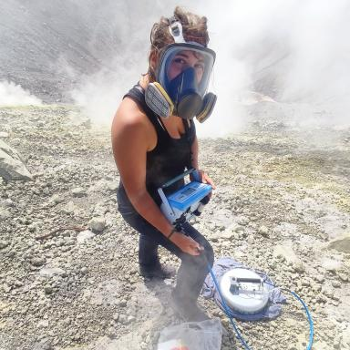 Victoria Rafflin

Identifiants chercheurs

- IdHAL : victoriarfln
- ORCID : 0000-0001-8000-9643

Publications

Article dans une revue (8)

Scientific response to the 2021–2022 seismic swarm in the Monts Dore volcanic province (France): dynamic insights from temporal surveys (2/2)
Guillaume Boudoire,Lydie Gailler,Jean Battaglia,Aude Beauger,Martial Bontempset al.
Comptes Rendus. Géoscience, 2025, 357, pp.79 - 103. ⟨10.5802/crgeos.285⟩
Article dans une revue
hal-05065074v1
Scientific response to the 2021–2022 seismic swarm in the Monts Dore volcanic province (France): structural insights from punctual surveys (1/2)
Lydie Gailler,Clément Grace,Guillaume Boudoire,Marc Grunberg,Jean Battagliaet al.
Comptes Rendus. Géoscience, 2025, 357, pp.61 - 78. ⟨10.5802/crgeos.284⟩
Article dans une revue
hal-05065079v1
Preferential Fluids Ascent Paths Revealed by Coupling Chemical, Electrical and Magnetic Methods: Insights for Risk Mitigation in a Long‐Dormant Volcanic Province (Monts Dore, France)
V. Rafflin,L. Gailler,C. Aumar,Nicolas Cluzel,Frédérick Galet al.
Journal of Geophysical Research : Solid Earth, 2025, 130 (5), ⟨10.1029/2024JB030308⟩
Article dans une revue
hal-05084687v1
Modelling CO2 dispersion in the air during potential limnic eruption at the lake Pavin (France)
Victoria Rafflin,Guillaume Boudoire,Silvia Massaro,Manuel Stocchi,Antonio Costaet al.
Journal of Volcanology and Geothermal Research, 2024, 447, pp.108024. ⟨10.1016/j.jvolgeores.2024.108024⟩
Article dans une revue
hal-04466178v1
Magma storage and degassing beneath the youngest volcanoes of the Massif Central (France): Lessons for the monitoring of a dormant volcanic province
Guillaume Boudoire,G. Pasdeloup,Federica Schiavi,Nicolas Cluzel,Victoria Rafflinet al.
Chemical Geology, 2023, 634, pp.121603. ⟨10.1016/j.chemgeo.2023.121603⟩
Article dans une revue
hal-04257727v1
Anatomy of thermal unrest at a hydrothermal system: case study of the 2021–2022 crisis at Vulcano
Sophie Pailot-Bonnétat,Victoria Rafflin,Andrew Harris,Iole Serena Diliberto,Gaetana Ganciet al.
Earth Planets and Space, 2023, 75, pp.159. ⟨10.1186/s40623-023-01913-5⟩
Article dans une revue
hal-04468586v1
Structured elicitation of expert judgement in real-time eruption scenarios: an exercise for Piton de la Fournaise volcano, La Réunion island
Alessandro Tadini,Andrew Harris,Julie Morin,Andrea Bevilacqua,Aline Peltieret al.
Volcanica, 2022, 5 (1), pp.105-131. ⟨10.30909/vol.05.01.105131⟩
Article dans une revue
hal-03712658v1
Scientific response to the 2021 eruption of Nyiragongo based on the implementation of a participatory monitoring system
Guillaume Boudoire,S. Calabrese,A. Colacicco,P. Sordini,P. Habakaramo Macumuet al.
Scientific Reports, 2022, 12, 327, p. 53-78. ⟨10.1038/s41598-022-11149-0⟩
Article dans une revue
insu-03825085v1

