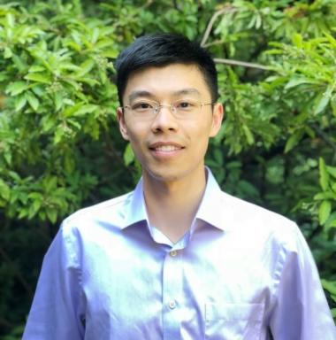 Xujia Zhu Maître de Conférences

Publications

Pré-publication, Document de travail (4)

MF-GLaM: A multifidelity stochastic emulator using generalized lambda models
Katerina Giannoukou,Xujia Zhu,Stefano Marelli,Bruno Sudret
2026
Pré-publication, Document de travail
hal-05589357v1
Conformal prediction for full and sparse polynomial chaos expansions
Arthur Hatstatt,Xujia Zhu,Bruno Sudret
2026
Pré-publication, Document de travail
hal-05481013v1
Seismic fragility analysis using stochastic polynomial chaos expansions
Xujia Zhu,Marco Broccardo,Bruno Sudret
2022
Pré-publication, Document de travail
hal-03787363v1
Stochastic polynomial chaos expansions to emulate stochastic simulators
Xujia Zhu,Bruno Sudret
2022
Pré-publication, Document de travail
hal-03610334v1

Article dans une revue (4)

Multi-point Bayesian active learning line sampling for rare event estimation
Pei Pei,Tong Zhou,Xujia Zhu,Tong Guo,Ser Tong Quek
Reliability Engineering and System Safety, 2026, 270, pp.112136. ⟨10.1016/j.ress.2025.112136⟩
Article dans une revue
hal-05590603v1
Multi-point Bayesian active learning reliability analysis
Tong Zhou,Xujia Zhu,Tong Guo,You Dong,Michael Beer
Structural Safety, 2025, 114, pp.102557. ⟨10.1016/j.strusafe.2024.102557⟩
Article dans une revue
hal-04896079v1
A theoretically-consistent parallel enrichment strategy for Bayesian active learning reliability analysis
Tong Zhou,Tong Guo,Xujia Zhu,Masaru Kitahara,Jize Zhang
Computer Methods in Applied Mechanics and Engineering, In press
Article dans une revue
hal-04896094v1
Impact of ploidy and pathogen life cycle on resistance durability
Méline Saubin,Stéphane de Mita,Xujia Zhu,Bruno Sudret,Fabien Halkett
Peer Community Journal, 2021, 1, pp.e8. ⟨10.24072/pcjournal.10⟩
Article dans une revue
hal-03610230v1

Communication dans un congrès (2)

Use of generalized lambda models for seismic fragility analysis
Xujia Zhu,Marco Broccardo,Bruno Sudret
8th International Symposium on Reliability Engineering and Risk Management (ISRERM), Sep 2022, Hannover, Germany
Communication dans un congrès
hal-03788059v1
Introducing latent variables in polynomial chaos expansions to surrogate stochastic simulators
Xujia Zhu,Bruno Sudret
Proc. 13th International Conference on Structural Safety & Reliability, Tongji University, Shanghai (China), September 13-17, Sep 2022, Shanghai, China
Communication dans un congrès
hal-03789082v1

