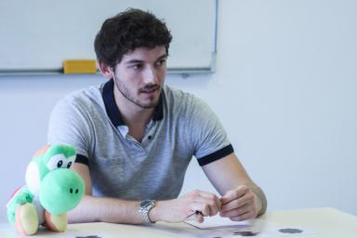 Yannick Lagarrigue

Identifiants chercheurs

- IdHAL : yannick-lagarrigue
- ORCID : 0000-0003-2905-7759
- IdRef : 255942311
- cv.identifier.google scholar : https://scholar.google.com/citations?user=87ykd7kAAAAJ&hl=fr&authuser=1

Publications

Article dans une revue (3)

Successful comparisons in novel word generalization: Executive functions or semantic knowledge?
Yannick Lagarrigue,Jean-Pierre Thibaut
Journal of Experimental Child Psychology, 2025, 252, pp.106130. ⟨10.1016/j.jecp.2024.106130⟩
Article dans une revue
hal-05571429v1
Regular rhythmic and audio-visual stimulations enhance procedural learning of a perceptual-motor sequence in healthy adults: A pilot study
Yannick Lagarrigue,Céline Cappe,Jessica Tallet
PLoS ONE, 2021, 16 (11), pp.e0259081. ⟨10.1371/journal.pone.0259081⟩
Article dans une revue
hal-03653811v1
Apprendre et généraliser de nouveaux noms : les leçons de la comparaison
Yannick Lagarrigue,Jean-Pierre Thibaut
Enfance, 2021, 2021 (2), pp.143-159. ⟨10.3917/enf2.212.0143⟩
Article dans une revue
hal-03278407v1

Thèse (1)

Apprentissage et généralisation de nouveaux concepts chez l’enfant par la comparaison de stimuli
Yannick Lagarrigue
Psychologie. Université Bourgogne Franche-Comté, 2022. Français. ⟨NNT : 2022UBFCK034⟩
Thèse
tel-03852371v1

Poster de conférence (2)

Solid ground makes solid understandings: does simple comparison paves the way for more complex comparisons ?
Yannick Lagarrigue,Jean-Pierre Thibaut
CogSci 2021 : Comparative Cognition Animal Minds, Jul 2021, Vienne, Austria. , Proceedings of the Annual Meeting of the Cognitive Science Society (e-ISSN: 1069-7977), 43, pp.3-C-102, 2021
Poster de conférence
hal-03355310v1
From two to many: The role of executive functions in young children’s generalization of novel object names in a comparison design
Yannick Lagarrigue,Jean-Pierre Thibaut
42nd Annual Virtual Meeting of the Cognitive Science Society (COGSCI 2020), Jul 2020, Virtuel Conference, United States
Poster de conférence
hal-04344142v1

Communication dans un congrès (2)

From two to many: The role of executive functions in young children's generalization of novel object names in a comparison design
Yannick Lagarrigue,Jean-Pierre Thibaut
Annual Conference of the Cognitive Science Society, 2020, Virtual, United States
Communication dans un congrès
hal-03814501v1
Solid ground makes solid understandings: does simple comparison paves the way for more complex comparisons?
Yannick Lagarrigue,Jean-Pierre Thibaut
Annual Meeting of the Cognitive Science Society, Cognitive Science Society, Jul 2020, Austin (TX), United States. pp.2726-2732
Communication dans un congrès
hal-04338739v1

