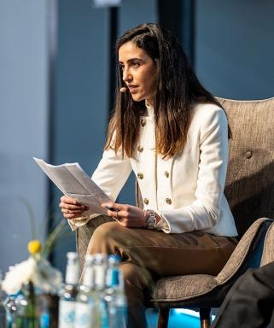 YASMINA ASRARGUIS PhD researcher on the Middle East Peace at La Sorbonne-Nouvelle University and research fellow within the Jean-Jaures Foundation. Graduate student of Sciences Po Paris (PSIA) and the University of Bath - specialized on international security, peace and stability in the Middle East.

Publications

Rapport (2)

Entretien exclusif avec l'Ambassadeur Michel Duclos
Meriem Naili,Yasmina Asrarguis
Institut Open Diplomacy. 2023, pp.105-111
Rapport
hal-04916044v1
The Abraham Accords Report
Yasmina Asrarguis,Barak Ravid,Erel Margalit,Martin Indyk,Aron David Miller
Sciences Po. 2023
Rapport
hal-04579924v1

