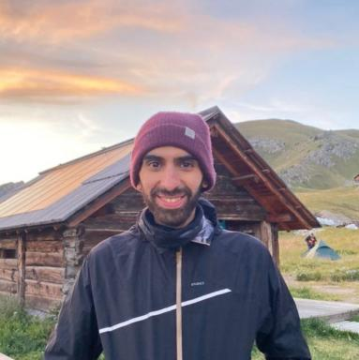 Yassine Mhiri Doctorant au laboratoire SATIE (ENS Paris-Saclay)

Identifiants chercheurs

- IdHAL : yassine-mhiri
- ORCID : 0000-0002-8435-7976
- arXiv : mhiri_y_1

Présentation

I am a Phd Student in statistical signal processing applied to radioastronomy, supervised by Pascal Larzabal, Mohammed Nabil EL Korso and Arnaud Breloy within the signal processing group (MOSS) of the SATIE laboratory at Paris-Saclay University.
Before that, I was a research engineer at Phasics where i helped conceive and develop algorithmic solutions for wavefront sensor analysis.
My current research interests lie in robust signal processing, statistical learning, structured covariance matrix estimation, interferometry and sensor array processing.

Publications

Article dans une revue (1)

Multifrequency array calibration in presence of radio frequency interferences
Yassine Mhiri,Mohammed Nabil El Korso,Arnaud Breloy,Pascal Larzabal
Signal Processing, 2022, 199, pp.108613. ⟨10.1016/j.sigpro.2022.108613⟩
Article dans une revue
hal-03953256v1

Communication dans un congrès (3)

Unrolled Expectation Maximization for Sparse Radio Interferometric Imaging
Nawel Arab,Yassine Mhiri,Isabelle Vin,Mohammed Nabil El Korso,Pascal Larzabal
32nd European Signal Processing Conference (EUSIPCO), Aug 2024, Lyon, France. pp.2197-2201, ⟨10.23919/EUSIPCO63174.2024.10715472⟩
Communication dans un congrès
hal-05136860v1
A Robust EM Algorithm for Radio Interferometric Imaging in The Presence of Outliers
Yassine Mhiri,Mohammed Nabil El Korso,Arnaud Breloy,Pascal Larzabal
SiPS22-IEEE Workshop on Signal Processing Systems, Nov 2022, Rennes, France. pp.1-5, ⟨10.1109/SiPS55645.2022.9919255⟩
Communication dans un congrès
hal-03823295v1
Expectation-Maximization Based Direction of Arrival Estimation Under a Mixture of Noise
Yassine Mhiri,Mohammed Nabil El Korso,Lucien Bacharach,Arnaud Breloy,Pascal Larzabal
EUSIPCO, Aug 2021, Dublin ( virtual ), Ireland. ⟨10.23919/EUSIPCO54536.2021.9615971⟩
Communication dans un congrès
hal-03156738v1

