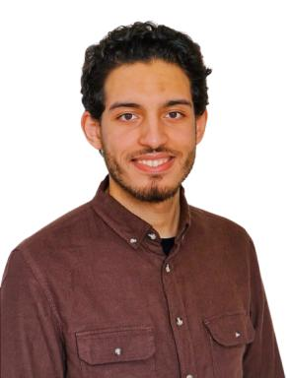 Youness HSANA

Identifiants chercheurs

- IdHAL : youness-hsana
- ORCID : 0009-0007-2879-8156

Publications

