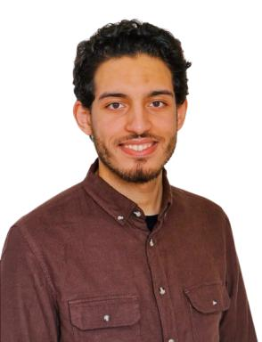 Youness HSANA

Identifiants chercheurs

- IdHAL :
youness-hsana
- ORCID :
0009-0007-2879-8156

Publications

