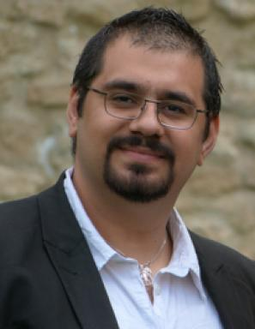 youva aoun

Présentation

Publications

Article dans une revue (4)

Monitoring aerosols over Europe: an assessment of the potential benefit of assimilating the VIS04 measurements from the future MTG/FCI geostationary imager
Maxence Raymond Descheemaecker,Matthieu Plu,Virginie Marecal,Marine Claeyman,Francis Olivieret al.
Atmospheric Measurement Techniques, 2019, 12 (2), pp.1251-1275. ⟨10.5194/amt-12-1251-2019⟩
Article dans une revue
hal-02051475v1
A new method for estimating UV fluxes at ground level in cloud-free conditions
William Wandji Wandji Nyamsi,Mikko R. A. Pitkänen,Youva Aoun,Philippe Blanc,Anu Heikkiläet al.
Atmospheric Measurement Techniques, 2017, 10 (12), pp.4965-4978. ⟨10.5194/amt-10-4965-2017⟩
Article dans une revue
hal-01667372v1
A database of multi-year (2004–2010) quality-assured surface solar hourly irradiation measurements for the Egyptian territory
Mohamed Korany,Mohamed Boraiy,Yehia Eissa,Youva Aoun,Magdy Abdel Wahabet al.
Earth System Science Data, 2016, 8, pp.105-113. ⟨10.5194/essdd-8-737-2015⟩
Article dans une revue
hal-01280702v1
Validation of the surface downwelling solar irradiance estimates of the HelioClim-3 database in Egypt
Yehia Eissa,Mohamed Korany,Youva Aoun,Mohamed Boraiy,Magdy Abdel Wahabet al.
Remote Sensing, 2015, 7, pp.9269-9291. ⟨10.3390/rs70709269⟩
Article dans une revue
hal-01180379v1

Communication dans un congrès (3)

An OSSE estimation of the capacity of FCI to improve aerosols forecast, by assimilating observations of aerosols optical thickness in MOCAGE CTM: Preliminary results
Descheemaecker Mathieu,Matthieu Plu,Virginie Marecal,Marine Claeyman,Sandrine Mathieuet al.
2017 EUMETSAT Meteorological Satellite Conference, Oct 2017, Rome, Italy
Communication dans un congrès
hal-01689370v1
THE USE OF GLOBAL SENSITIVITY ANALYSIS FOR ASSESSING CAPABILITY OF THE MTG/FCI INSTRUMENT TO DETECT AEROSOLS
Youva Aoun,Philippe Blanc,Lucien Wald,Sandrine Mathieu,Marine Claeyman
2015 EUMETSAT Meteorological Satellite Conference, EUMETSAT, Sep 2015, Toulouse, France. Aoun.pdf
Communication dans un congrès
hal-01290979v1
Preliminary study of the FCI instrument capability to detect dust aerosols
Youva Aoun,Philippe Blanc,Lucien Wald,Sandrine Mathieu,Marine Claeyman
EUMETSAT Meteorological Satellite Conference 2014, EUMETSAT, Sep 2014, Geneve, Switzerland
Communication dans un congrès
hal-01147807v1

Autre publication scientifique (1)

Les aérosols atmosphériques, qu’est-ce que c’est ?
Youva Aoun
2014, 19 p
Autre publication scientifique
hal-01555621v1

