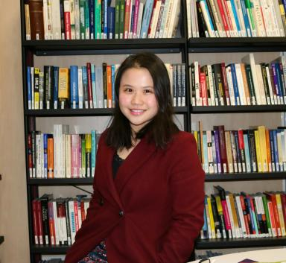 Zhe YUAN

Identifiants chercheurs

- IdHAL : zhe-yuan

Présentation

Zhe YUAN is a PhD student in Laboratoire Génie Industriel (LGI) Centrale Supélec since November 2015.
Thesis: Flexibility management in supply chains
Education background:
2015-now, PhD candidate, Operations Management, Centrale Supélec (France)
2013-2015, Master of Engineering, Logistic Engineering, Huazhong University of Science and Technology (China)
Contact me
Laboratoire Genie Industriel Centrale Supélec, Université Paris-Saclay
Grande Voie des Vignes 92290 Chatenay-Malabry, France
Phone : +33 (0)1 41 13 18 15
E-mail : zhe.yuan@centralesupelec.fr
Office : Building Dumas, D411

Publications

